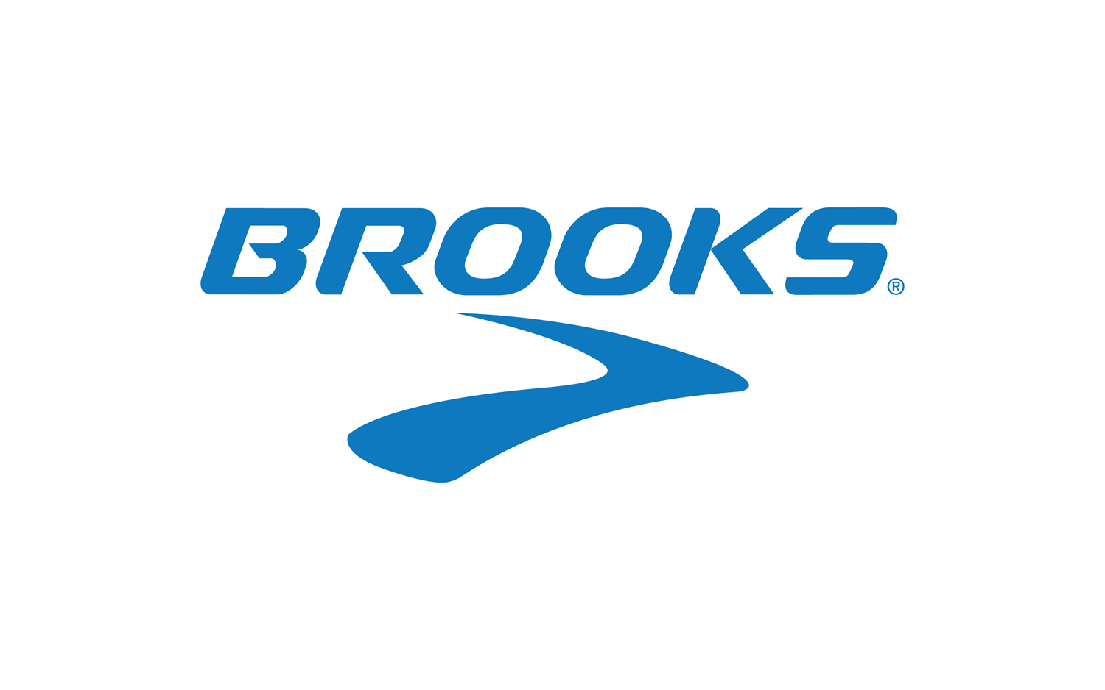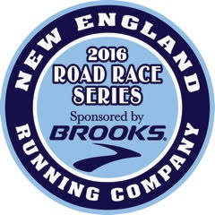
Brooks 2016 North Shore Road Race Series
The 3rd and final year of the series! Win a trip to Seattle!!
All runners who complete the 8 races in series (in addition to a jacket) will be placed in a raffle to win a trip to Seattle in 2017, 3 days and 2 nights, to attend a Red Sox/Mariner game and visit Brooks headquarters or win a trip and entry to 2017 Seattle Marathon!
Brooks Sports Company and New England Running Company (NERC) are hosting a race series for 2016. There will be eight racing events offered, and finishers of all 8 races will receive a high quality Brooks running apparel item, to be announced soon. Those who can only complete 7 of the 8 races will receive a Brooks technical shirt. The Brooks Race Series gives runners a chance to experience a variety of races on the North Shore in Salem, Beverly, Gloucester, and Danvers. All races support local non-profit agencies and charities, so your hard work will not only be rewarded, but will help benefit community programs on the North Shore. The 2016 race series includes:
1) Friday, January 1: Frosty Four New Year’s Day Race, Salem, 10 a.m., 4 miles: A relatively flat course, some rolling hills. In partnership with the Wicked Running Club; a portion of proceeds will support youth scholarships.
2) Sunday, May 1 : The Tapleyville 7 Mile run Danvers, Ma 9:30 a.m. 7.1 miles: New course which incorporates part of weekly D5K and the new trail. Proceeds benefit Boys & Girls Club of Greater Salem and the Alzheimer Association.
3) Sunday, June 19: New England Running Company 10 Miler, Beverly, 7:30 a.m., 10 miles: This race starts and finishes at the Cove Community Center and follows scenic Route 127. Proceeds benefit the Boys & Girls Club of Greater Salem and the Alzheimer’s Association.
4) Friday, July 8 Annual Miles Over the Moon, Salem, 8 p.m., 4 miles: A relatively flat course run thru the Salem Willows. This event is hosted by the Wicked Running Club, with a portion of the proceeds donated to local high school track programs.
5) Sunday, August 7 Bridge & Back 10K, Salem, 8 a.m., 6.2 miles: This race kicks off Heritage Week in Salem, and starts and finishes at The Tavern in the Square in Salem. The race crosses the Salem/Beverly Bridge, through Beverly and returns back over the bridge to Salem. All proceeds benefit the Boys & Girls Club of Greater Salem.
6) Sunday, September 18: Lone Gull 10K, Gloucester, 9 a.m., 6.2 miles: A Beautiful, fast 10K course with slight rolling hills along the backshore of Gloucester and Eastern Point. A “must run” race, Lone Gull was the winner of The North Shore Road Race Guide Best Race Course and Best 10K Race in 2012. Proceeds go to the Beverly School for the Deaf.
7) Sunday, October 2: The Fall Frolic 5k, Beverly, 9:30 a.m., 3.1 miles: This flat, fast race starts at Lynch Park and follows a paved route through Beverly neighborhood (Beverly Homecoming route). A great family run with proceeds to the five (5) Beverly Elementary Schools.
8) Thursday, November 24: Wild Turkey 5 Mile Run, Salem, 8 a.m., 5 miles: This Thanksgiving Day event follows a fairly flat course along a scenic, waterfront route. Voted Best Holiday race by the North Shore Road Race Guide. Proceeds benefit Boys & Girls Club of Greater Salem. There is no fee to participate in the 2016 Race Series (aside from the race registration fees). Races may be subject to change.
Just fill out this application and return it by 1/1/16 to be eligible for a shirt (finish 7 races) or a jacket (finish all 8)!
---------------------------------------------------------------------------------------------------------------------------------------------------------------------------------------------------
YES! Please enter me into the Brooks 2016 Road Race Series: (races may be subject to change).
Unisex Sizes (Circle One): XS, S M, L, XL (Shirt for finishing 7 races; jacket if you finish all 8. One item per finisher)
Name:______________________________________________________ Age (as of 1/1/16):______ Circle One: Male Female
Email______________________________________________________Address:__________________________________________ City:_________________________ State:_____ Zip:________Return by 1/1/16 to: dougbollen12@yahoo.com or Doug Bollen, Boys & Girls Clubs, c/o 2015 Brooks Race Series, PO Box 24, Salem, MA 01970

