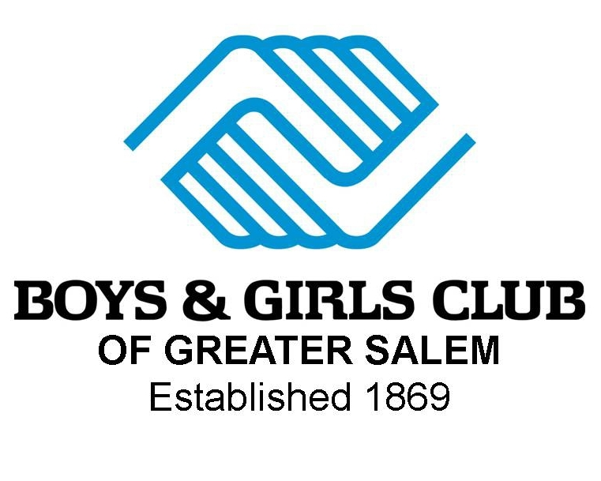

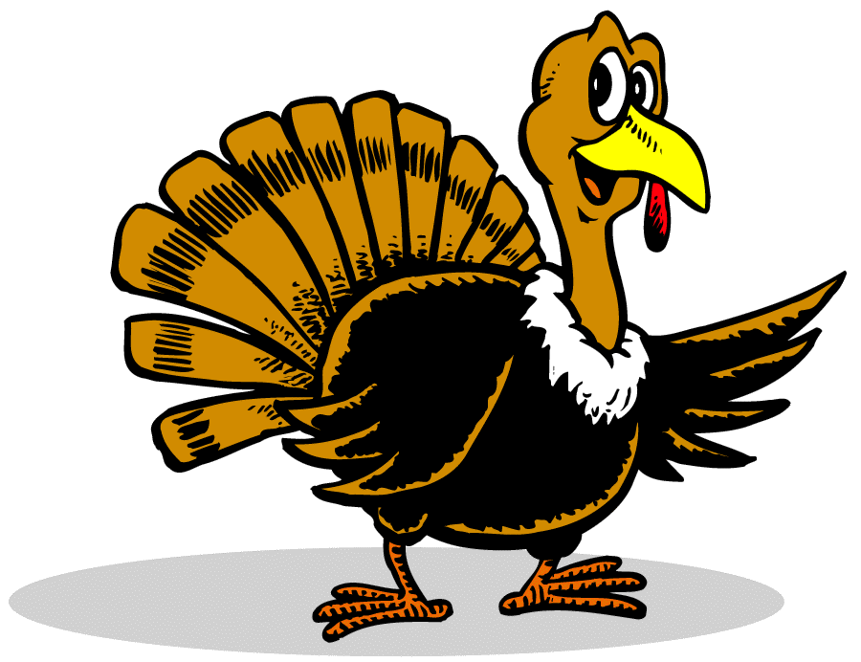
The Boys & Girls Club of Greater Salem
The 11th Annual
“Wild Turkey 5 Mile Run!”

Thanksgiving Day, November 27, 2014 @ Knights of Columbus Hall on the Salem Common, 94 Washington Square, Salem, Ma.
Race starts 8:00 am
USTFA Certification number MA10030JK

Pre-race packet pick up w/ numbers & shirt plus a chance to win a free pair of Brooks running shoes on November 25 & 26 from 10 a.m. –7 p.m. at: New England Running Company, Commodore Plaza, 43 Enon St., Beverly or pick up race day from 7 a.m. at Boys & Girls Club, 13 Hawthorne Blvd., Salem

Entry Fee: $24 pre registration; $27 race day
**** CHIP TIMING on Bib number provided by Racewire.com
Register Early: Long Sleeve Brooks Technical Shirts for first 1300 entrants!
(Sorry, shirt sizes cannot be guaranteed)

Awards: Overall winner male and female, and top three males & females in each category:
14 & under, 15-19, 20-24, 25-29, 30-34, 35-39, 40-44, 45-49,

50-54, 55-59, 60-64, 65-69, 70 & over
Post Race: refreshment, awards and raffles at Boys & Girls Club
Info: Boys & Girls Club of Greater Salem (978) 744-0915 or
Email: dougbollen12@yahoo.com
-----------------------------------------------------------------------------------------------------------------------------------------
Name:_____________________________________________ Age:____ Male:_____ Female:_____

Address:__________________________________________ City:______________ State:________
Zip:___________Phone:____________________EMAIL:__________________________________
Date:__________________________ Shirt Size: XS___ S___M___L___ XL__(Size cannot be guaranteed)

Signature__________________________________________________________________________
(parent or guardian signature required if under 18 yrs of age)
Send registration and check to: Boys & Girls Club of Greater Salem, c/o Wild Turkey Run!
13 Hawthorne Blvd Salem, MA 01970. Proceeds from the Wild Turkey support Salem youth programs.
In consideration of this entry being accepted, I hereby for myself, heirs, executers and administrators waive and hereby release any and all rights and claim or damages I may have against the Boys & Girls Club of Greater Salem, Immaculate Conception Church and the city of Salem of any and all injuries suffered at said event, while traveling to or returning therefrom.

