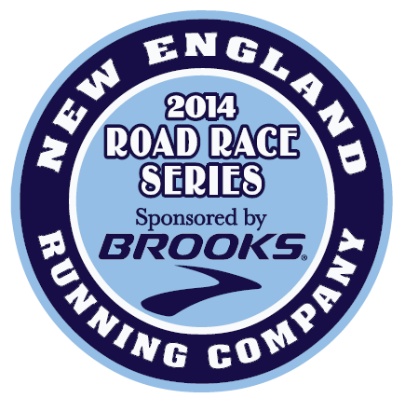

New England Running Company 2014 Race Series

sponsored by Brooks Sports Company
Brooks Sports Company and New England Running Company are hosting a new race series for 2014. There will be eight racing events offered, and finishers of all 8 races will receive a Brooks running jacket. Those who can only complete 7 of the 8 races will receive a Brooks technical shirt. The Brooks Race Series gives runners a chance to experience a variety of races on the North Shore in Salem, Beverly, Gloucester and Marblehead. All races support local non-profit agencies and charities, so your hard work will not only be rewarded, but will help benefit community programs on the North Shore. The 2014 race series includes:
1) Wednesday, January 1: Frosty Four New Year’s Day Race, Salem, 10 a.m., 4 miles: A relatively flat course, some rolling hills. In partnership with the Wicked Running Club; a portion of proceeds will support youth scholarships.
2) Saturday, May 10: Beach to Beach 5K Walk/Run, Marblehead, 9 a.m., 3.1 miles: Race proceeds go to the Junior Aid Society, Inc., a non-profit organization founded in 1912 that supports women's and children's charities on Boston's North Shore.
3) Sunday, June 22: New England Running Company 10 Miler, Beverly, 7:30 a.m., 10 miles: This new race starts at Lynch Park and follows scenic Route 127. Proceeds benefit the Boys & Girls Club of Greater Salem and the Alzheimer Disease Foundation.
4) Friday, July 11: 4th Annual Miles Over the Moon, Salem, 8 p.m., 4 miles: A relatively flat course through the historic district of Salem. This event is hosted by the Wicked Running Club, with a portion of the proceeds donated to local high school track programs.
5) Sunday, August 3, Bridge & Back 10K, Salem, 8 a.m., 6.2 miles: This race kicks off Heritage Week in Salem, and starts and finishes at The Tavern in the Square in Salem. The race crosses the Salem/Beverly Bridge, through Beverly and returns back over the bridge to Salem. All proceeds benefit the Boys & Girls Club of Greater Salem.
6) Sunday, September 14: Lone Gull 10K, Gloucester, 9 a.m., 6.2 miles: A Beautiful, fast 10K course with slight rolling hills along the backshore of Gloucester and Eastern Point. A “must run” race, Lone Gull was the winner of The North Shore Road Race Guide Best Race Course and Best 10K Race in 2012. Proceeds go to the Beverly School for the Deaf.
7) Sunday, October 5: The Fall Frolic 5k, Beverly, 9:30 a.m., 3.1 miles: This flat, fast race starts at Lynch Park and follows a paved route through Beverly neighborhood (Beverly Homecoming route). A great family run with proceeds to the five (5) Beverly Elementary Schools.
8) Thursday, November 27: Wild Turkey 5 Mile Run, Salem, 8 a.m., 5 miles: This Thanksgiving Day event follows a fairly flat course along a scenic, waterfront route. Voted Best Holiday race by the North Shore Road Race Guide. Proceeds benefit Boys & Girls Club of Greater Salem.
There is no fee to participate in the 2014 Race Series (aside from the race registration fees). Races may be subject to change.
Just fill out this application and return it by 1/1/14 to be eligible for a shirt (finish 7 races) or a jacket (finish all 8)!
-----------------------------------------------------------------------------------------------------------------------------------------------------------------------------------------
YES! Please enter me into the Brooks 2014 Road Race Series: (races may be subject to change).
Unisex Sizes (Circle One): S, M, L, XL (Shirt for finishing 7 races; jacket if you finish all 8. One item per finisher)
Name:______________________________________________________ Age (as of 1/1/14):______ Circle One: Male Female
Day Phone ________________________________Email__________________________________________________________
Address:_________________________________________________________ City:_________________________ State:_____ Zip:________
Return by 1/1/14 to: Doug Bollen, Boys & Girls Clubs, c/o 2014 Brooks Race Series, 13 Hawthorne Blvd., Salem, MA 01970

